1. Top of Form

Comprehensive Visualisation Report: Insights and Data Analysis Perspectives

## Introduction

This report presents a detailed series of visualisations crafted to provide a holistic understanding of various crucial facets within a comprehensive healthcare dataset. Each visualisation serves a distinct purpose, offering invaluable insights essential for robust data analysis, informed strategic planning, and effective operational decision-making within the healthcare sector. From tracking the prevalence of patient allergies to analysing complex financial coverage patterns, these visual tools are designed to illuminate trends, highlight key relationships, and facilitate a deeper understanding of healthcare dynamics over time and across different patient cohorts.

## 1. Allergies

**Visual 1: Stacked Bar Chart – Count of Patients by Description and Code**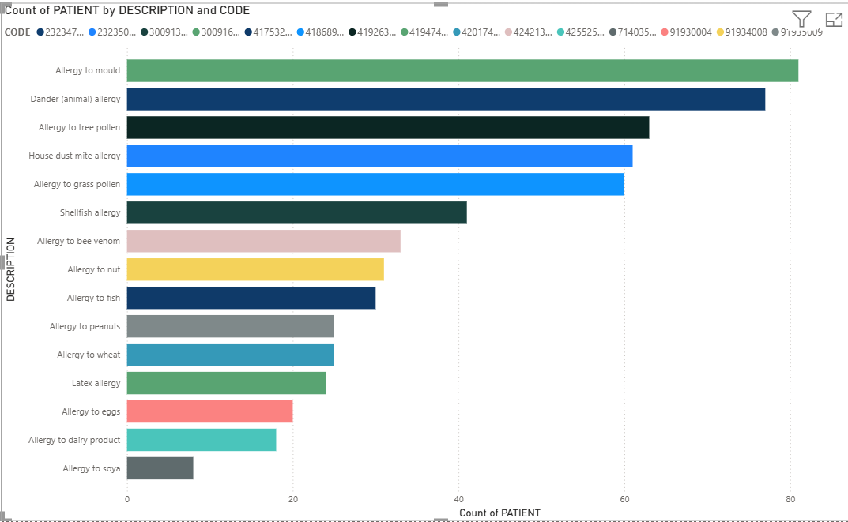

• **Visualisation Type and Purpose:** This stacked bar chart meticulously organises patient allergies by their clinical description and corresponding SNOMED code, illustrating the prevalence of specific allergens within the patient population.

• **Key Insights:** The chart efficiently identifies the most frequently documented allergies, thereby enhancing clinical awareness of common patient sensitivities and facilitating comparisons across diverse allergen types.

• **Data Analysis Perspective:** This visualisation is fundamental for understanding the epidemiological landscape of allergies within the patient cohort. It enables resource allocation for common allergens, supports targeted public health initiatives, and can inform the development of clinical guidelines for allergy management.

**Visual 2: Line Chart – Count of Encounters by Year**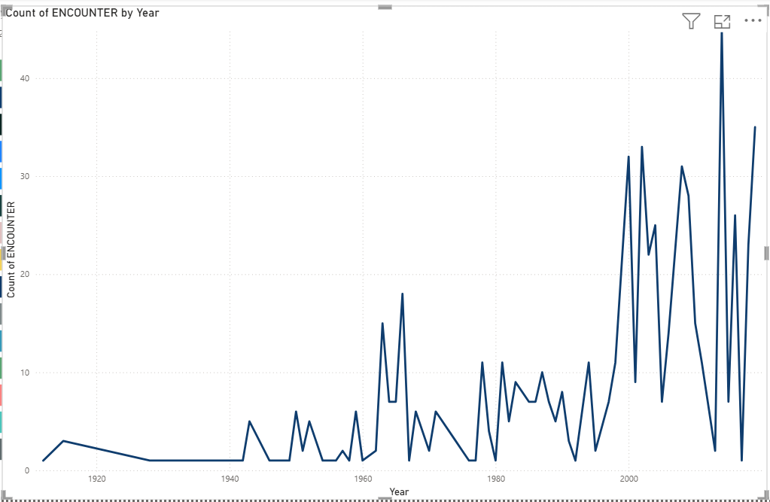

• **Visualisation Type and Purpose:** A time-series line chart tracks the annual count of encounters where allergies were recorded, providing a longitudinal view of documentation trends.

• **Key Insights:** Fluctuations (peaks or troughs) in this timeline can indicate shifts in clinical recording practices, simulated epidemiological changes, or an increase in allergy awareness within the dataset.

• **Data Analysis Perspective:** This visual supports historical trend analysis, allowing analysts to identify system-wide changes in documentation behaviours, assess the impact of awareness campaigns, or model simulated public health trends related to allergies over time.

## 2. Careplans

**Visual: Line Chart – Count of Patients by Start Year**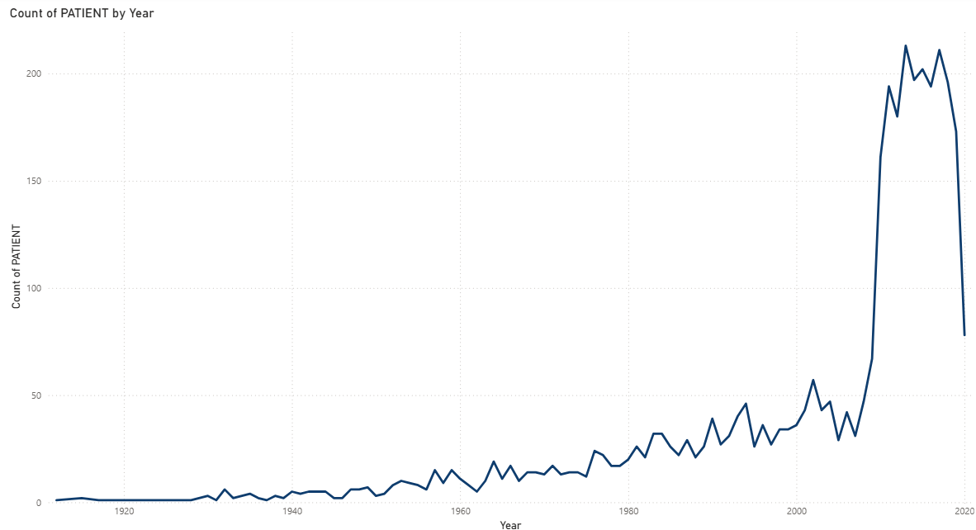

• **Visualisation Type and Purpose:** This line chart depicts the annual count of patients initiating a careplan, highlighting year-on-year variations and long-term trends in structured care management adoption.

• **Key Insights:** Upward trends signify increased utilisation of careplans, reflecting a greater emphasis on long-term disease management and continuity of care. Conversely, declines or abrupt shifts may indicate changes in clinical priorities, patient demographics, or documentation protocols.

• **Data Analysis Perspective:** This analysis is vital for assessing the effectiveness and adoption rates of care management strategies. It helps identify trends in chronic disease management, evaluates the impact of care coordination initiatives, and can pinpoint periods of significant change in healthcare delivery models.

## 3. Conditions

**Visual: Pie Chart – Count of Encounters by Description and Code**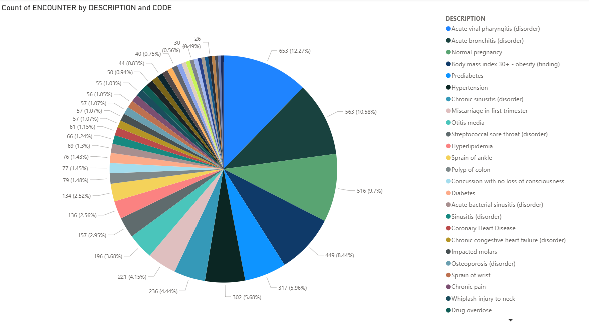

• **Visualisation Type and Purpose:** A pie chart illustrates the distribution of clinical conditions based on their encounter frequency, with each condition identified by both description and code for accuracy.

• **Key Insights:** This chart clearly identifies the most prevalent conditions driving patient visits, revealing the simulated burden of disease in the population. Larger slices represent conditions with higher encounter frequencies, indicating their dominance.

• **Data Analysis Perspective:** This is an essential tool for understanding disease prevalence and impact. It informs resource planning, prioritises public health strategies based on the most common health issues, and guides the development of targeted intervention programmes.

## 4. Devices

**Visual: Line and Stacked Column Chart – Count of UDI and Count of Patients by Description**

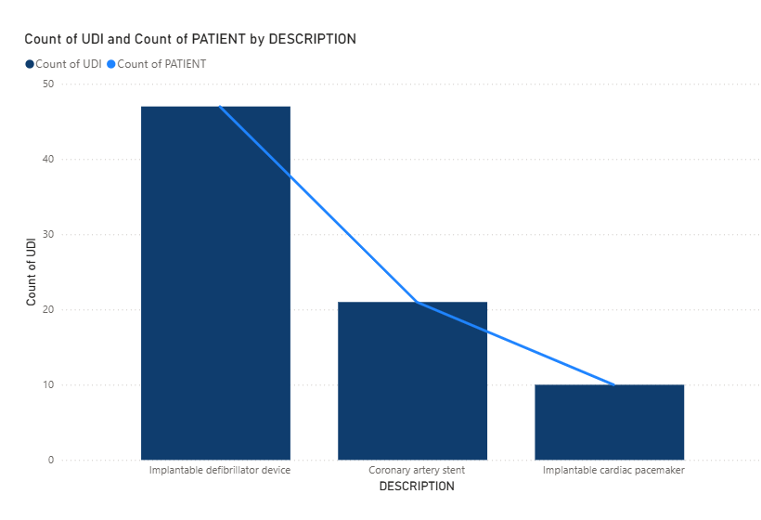

• **Visualisation Type and Purpose:** This dual-axis chart combines columns representing the number of unique device identifiers (UDI) for each device description with a line tracking the number of patients associated with those devices.

• **Key Insights:** The chart simultaneously highlights both device prevalence and patient impact. For instance, implantable defibrillators may show the highest UDI count and affect the largest number of patients, providing context on device adoption patterns.

• **Data Analysis Perspective:** This visual offers a critical dual perspective on medical device adoption, market penetration, and patient care impact. It can inform procurement decisions, inventory management strategies, and patient safety monitoring related to device usage.

## 5. Encounters

**Visual 1: Stacked Area Chart – Total Claim Cost and Base Encounter Cost by Year**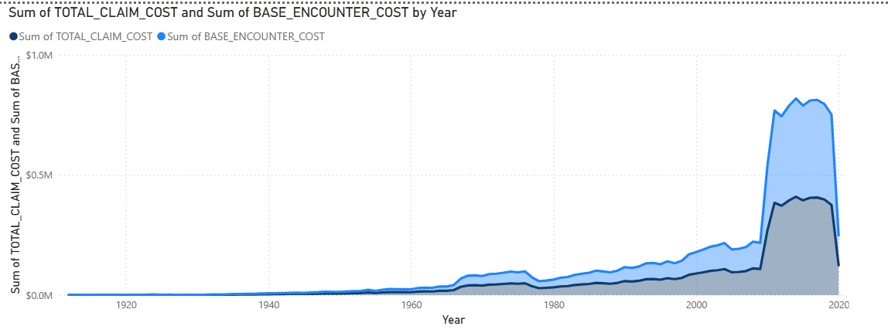

• **Visualisation Type and Purpose:** This stacked area chart tracks the sum of Total Claim Cost and Base Encounter Cost annually, illustrating both individual components and their combined contribution to overall healthcare expenditure.

• **Key Insights:** The chart illuminates cost trends in patient encounters. A widening gap between base costs and total claim costs may suggest the growing influence of additional services, payer adjustments, or supplemental charges.

• **Data Analysis Perspective:** This visual is critical for financial forecasting, cost management, and identifying the key drivers of healthcare expenditure increases. It can help pinpoint areas of potential inefficiency or cost escalation within the healthcare system.

**Visual 2: Pie Chart – Count of Patients by Encounter Class**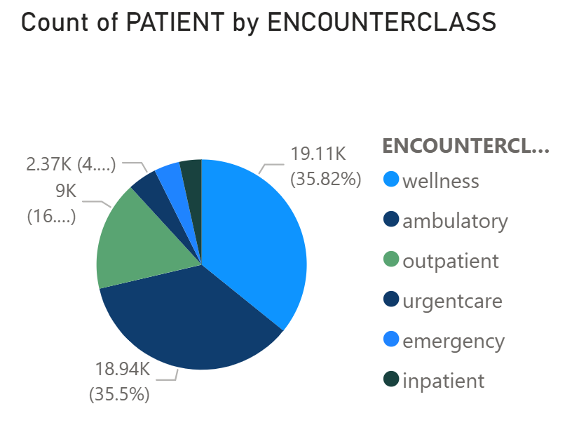

• **Visualisation Type and Purpose:** This pie chart categorises patients by encounter type (e.g., wellness, ambulatory, outpatient, inpatient, emergency), emphasising the proportional distribution of patient activity across these classes.

• **Key Insights:** A larger proportion of wellness or ambulatory visits may signify robust preventive care within the dataset, whereas higher inpatient or emergency encounters underscore acute care demands.

• **Data Analysis Perspective:** This visual provides valuable insight into healthcare system utilisation patterns, the effectiveness of preventive care strategies, and supports capacity planning for different service lines within healthcare facilities.

**Visual 3: Clustered Column Chart – Sum of Payer Coverage by Payer and Encounter Class**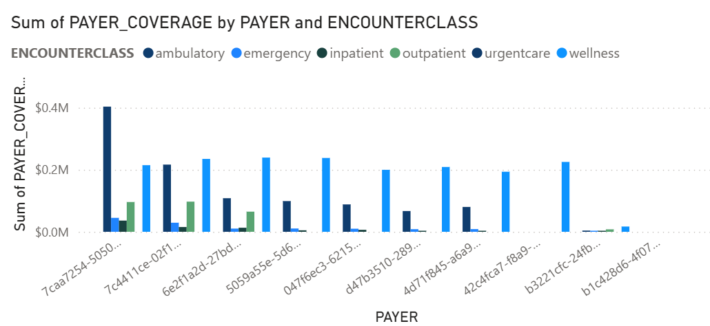

• **Visualisation Type and Purpose:** This clustered column chart cross-analyses payer coverage amounts against specific payer organisations and encounter classes, enabling direct comparison of financial coverage patterns.

• **Key Insights:** The visualisation reveals how different payers allocate resources across various types of care, highlighting payer-specific strengths or gaps in coverage, which is useful for financial and insurance-related analysis.

• **Data Analysis Perspective:** This chart facilitates detailed financial and insurance analysis, aiding in the identification of payer-specific policies, market positioning, and areas for potential negotiation or policy adjustments in reimbursement.

## 6. Imaging Studies

**Visual 1: Ribbon Chart – Count of Patients by Body Site Description and Modality Description**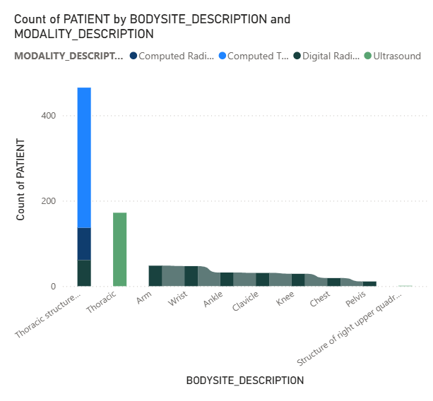

• **Visualisation Type and Purpose:** This ribbon chart combines body site descriptions (e.g., chest, abdomen, head) with modality descriptions (e.g., X-ray, MRI, CT), where ribbon width indicates patient counts and shifts in modality distribution across body sites.

• **Key Insights:** The chart provides a comparative view of imaging demand variation by body site and identifies which modalities dominate specific diagnostic contexts (e.g., chest X-rays may account for the widest ribbons).

• **Data Analysis Perspective:** This visual is crucial for informing equipment procurement, assessing staff training needs, and understanding diagnostic workflows tailored to different anatomical regions within imaging departments.

**Visual 2: Donut Chart – Count of Patients by Modality Description and SOP Code**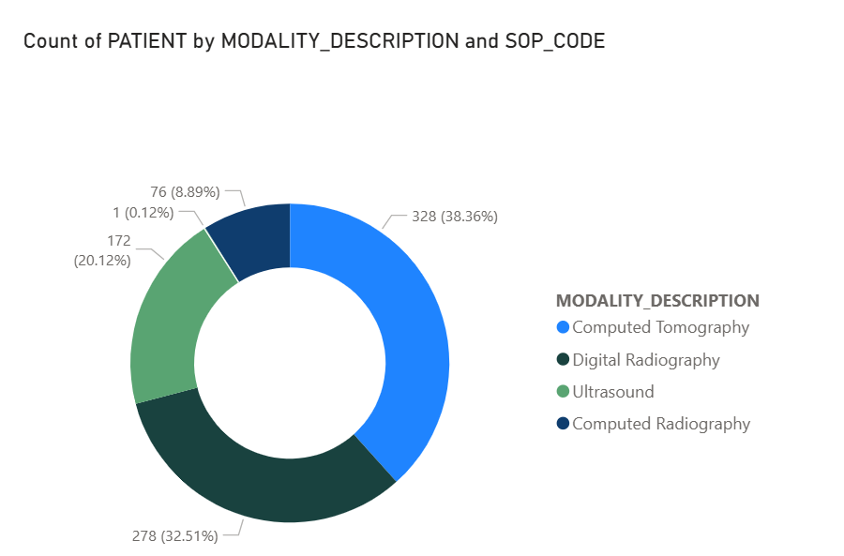

• **Visualisation Type and Purpose:** This donut chart segments imaging studies by modality description (e.g., CT, MRI, Ultrasound) and their associated standardised procedure (SOP) codes, highlighting the relative proportions of various imaging techniques.

• **Key Insights:** The visualisation clearly highlights the most commonly used imaging modalities in the dataset, with larger slices indicating dominant techniques and smaller slices representing less frequent diagnostic methods.

• **Data Analysis Perspective:** This is valuable for resource allocation, assessing the adoption of new technologies, and standardising imaging protocols to optimise efficiency and patient care.

## 7. Immunisations

**Visual: Treemap – Count of Encounters by Description and Code**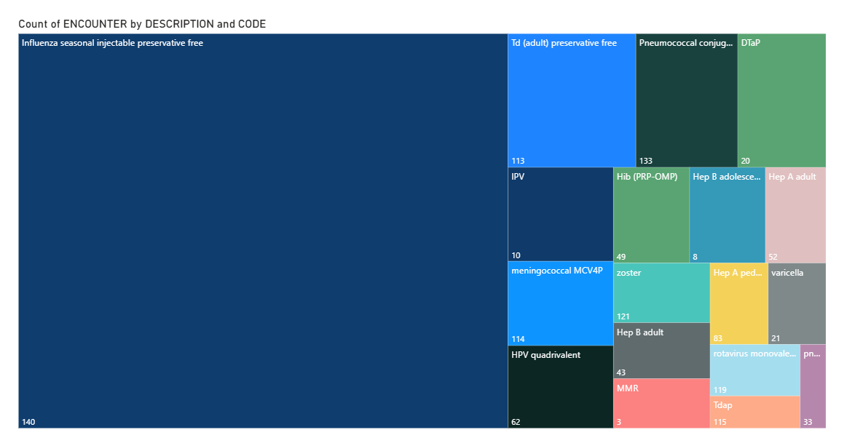

• **Visualisation Type and Purpose:** This treemap displays the distribution of immunisations by their clinical description and standard code, with block size corresponding to the number of encounters.

• **Key Insights:** Larger blocks promptly highlight vaccines that dominate the dataset, indicating higher uptake or broader coverage within the patient population, while smaller blocks represent less frequently administered immunisations.

• **Data Analysis Perspective:** This visual is essential for public health monitoring, assessing the effectiveness of vaccine programmes, and identifying areas where immunisation rates may need improvement or targeted interventions.

## 8. Medications

**Visual 1: Funnel Chart – Sum of Payer Coverage by Payer**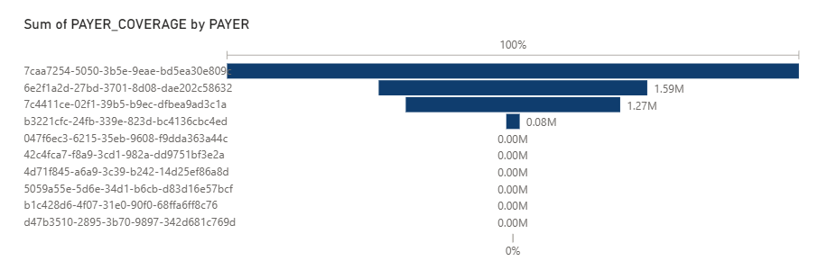

• **Visualisation Type and Purpose:** This funnel chart illustrates total payer coverage amounts for prescribed medications, grouped and ordered by payer from highest to lowest coverage.

• **Key Insights:** The chart highlights which payers are the most significant contributors to medication coverage. Larger funnel segments indicate payers with higher financial responsibility for prescriptions, while smaller ones reveal limited roles.

• **Data Analysis Perspective:** This visual supports comprehensive financial analysis of pharmaceutical spending, identifying key stakeholders in medication cost management and potential opportunities for price negotiation or formulary adjustments.

**Visual 2: Stacked Bar Chart – Count of Patients by Medication Description and Reason Description**

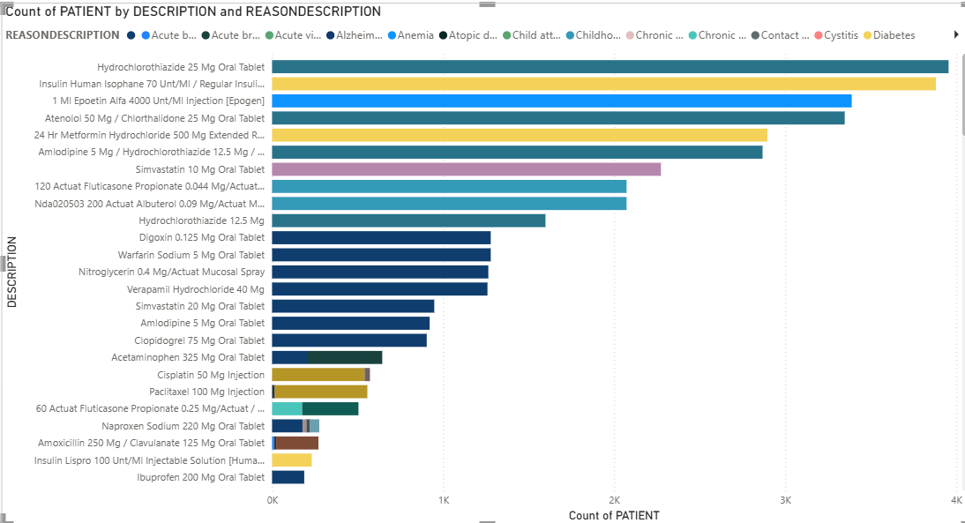

• **Visualisation Type and Purpose:** This stacked bar chart categorises medications by their clinical description (drug prescribed) and stacks them against the reason for prescription (underlying condition), allowing comparison of drug usage across different conditions.

• **Key Insights:** The visualisation offers a dual perspective: identifying the most frequently prescribed medications and the conditions driving those prescriptions, such as chronic conditions accounting for disproportionately high drug use.

• **Data Analysis Perspective:** This chart informs pharmacovigilance efforts, guides formulary management decisions, and helps in understanding drug utilisation patterns in relation to disease prevalence and adherence to treatment protocols.

## 9. Observations

**Visual: Line Chart – Count of Encounters by Quarter and Description**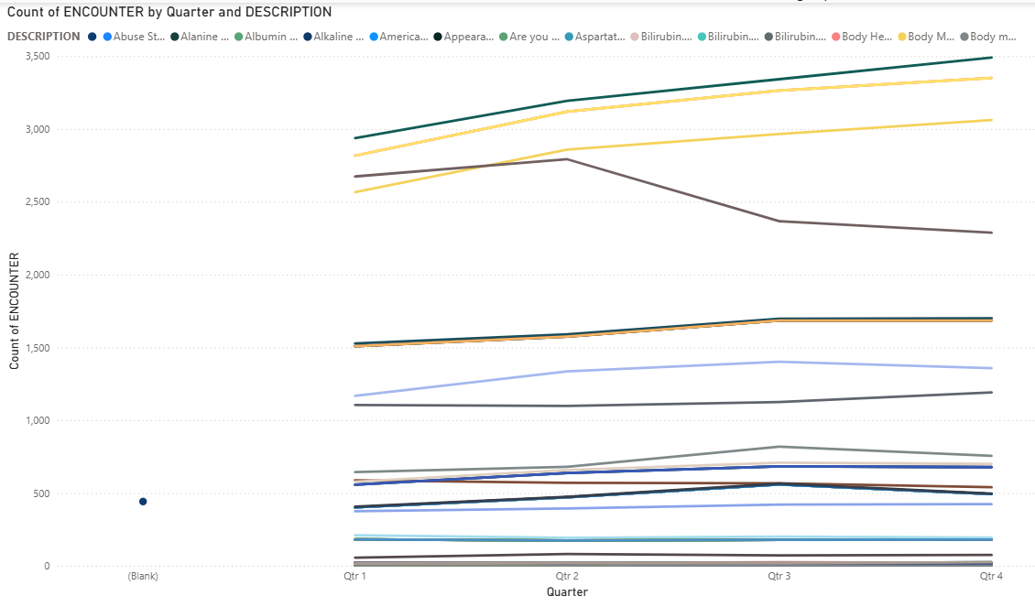

• **Visualisation Type and Purpose:** This line chart presents the frequency of clinical observations, grouped by quarter and broken down by observation description (e.g., vital signs, lab tests), emphasising changes over time and allowing comparison.

• **Key Insights:** The chart highlights seasonal or quarterly patterns in the recording of clinical observations. Certain types of observations may peak in specific periods, reflecting simulated healthcare cycles (e.g., flu season driving more temperature or respiratory observations).

• **Data Analysis Perspective:** This visual is useful for identifying cyclical healthcare activity, optimising resource planning for diagnostic services, and monitoring adherence to clinical guidelines, particularly in response to seasonal health challenges.

## 10. Organisations

**Visual: Map – Sum of Revenue by Latitude and Longitude**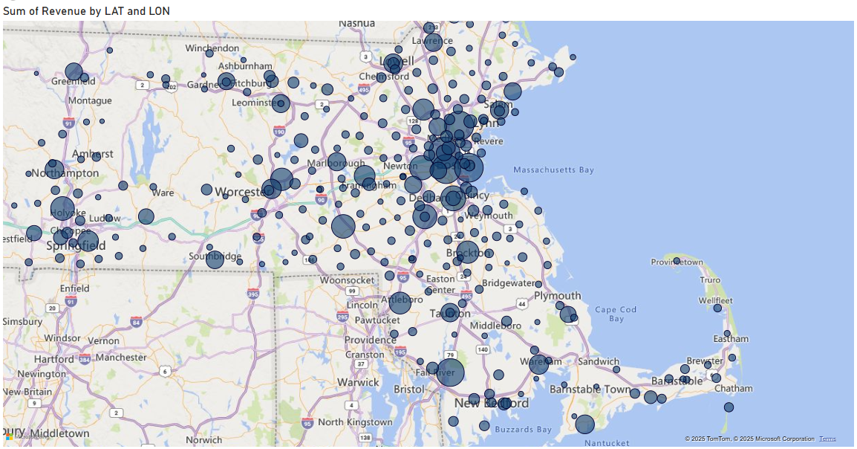

• **Visualisation Type and Purpose:** This map plots healthcare organisations geographically using their latitude and longitude, with marker size or intensity corresponding to the sum of revenue generated.

• **Key Insights:** The map highlights the geographic distribution of organisations and their relative revenue contributions. Clusters in certain areas suggest regions with higher healthcare activity or larger providers, indicating high-revenue hubs.

• **Data Analysis Perspective:** This visual supports regional economic analysis of healthcare, aids in market competitiveness assessment, and informs strategic planning for facility expansion or optimised resource deployment across geographic areas.

## 11. Patients

**Visual 1: Pie Chart – Sum of Healthcare Expenses by Gender**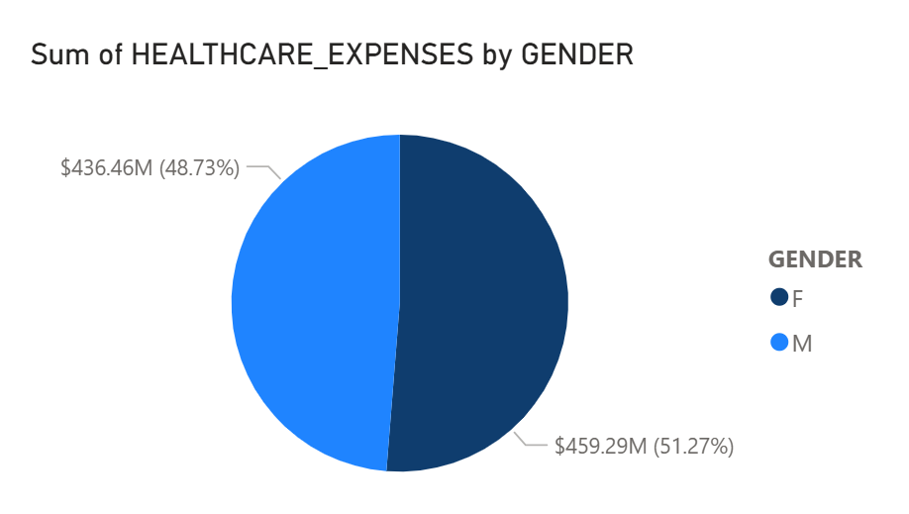

• **Visualisation Type and Purpose:** This pie chart categorises total healthcare expenses by patient gender, highlighting proportional spending differences.

• **Key Insights:** Differences in expense distribution may reflect variations in healthcare utilisation patterns, disease prevalence, or demographic characteristics between genders.

• **Data Analysis Perspective:** This chart is essential for understanding gender-specific health disparities, informing resource allocation decisions, and guiding the development of targeted health interventions.

**Visual 2: Pie Chart – Sum of Healthcare Coverage by Marital Status**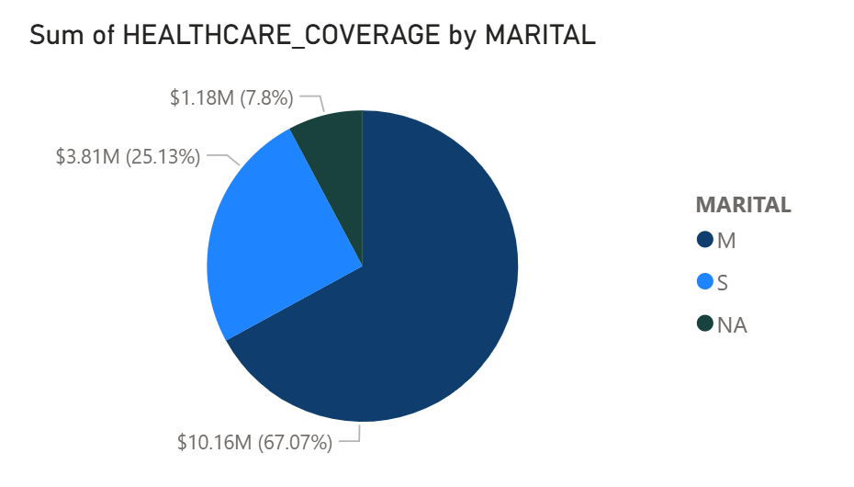

• **Visualisation Type and Purpose:** This chart presents the distribution of healthcare coverage amounts grouped by marital status, emphasising the relative contribution of each marital group to total coverage.

• **Key Insights:** The visualisation helps assess how coverage is distributed across demographic categories, potentially revealing socioeconomic patterns simulated within the dataset.

• **Data Analysis Perspective:** This provides insight into the socioeconomic determinants of health coverage, aiding in policy formulation and initiatives aimed at ensuring equitable access to healthcare.

**Visual 3: Pie Chart – Count of Patients by Ethnicity**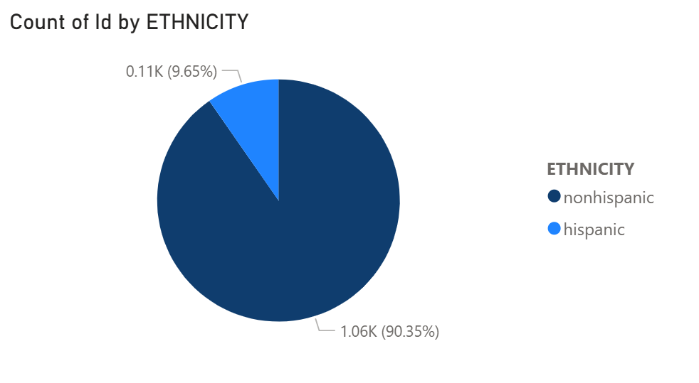

• **Visualisation Type and Purpose:** This chart shows the number of patients across different ethnic groups in the dataset, providing a proportional view of demographic diversity.

• **Key Insights:** The chart provides crucial demographic context for interpreting health trends across other dimensions, such as conditions, careplans, and encounters.

• **Data Analysis Perspective:** This visual is crucial for assessing health equity, identifying potential disparities in health outcomes or access to care among different ethnic groups, and tailoring culturally competent healthcare services.

## 12. Payer Transitions

**Visual: Stacked Column Chart – Count of Patients by Payer and Ownership**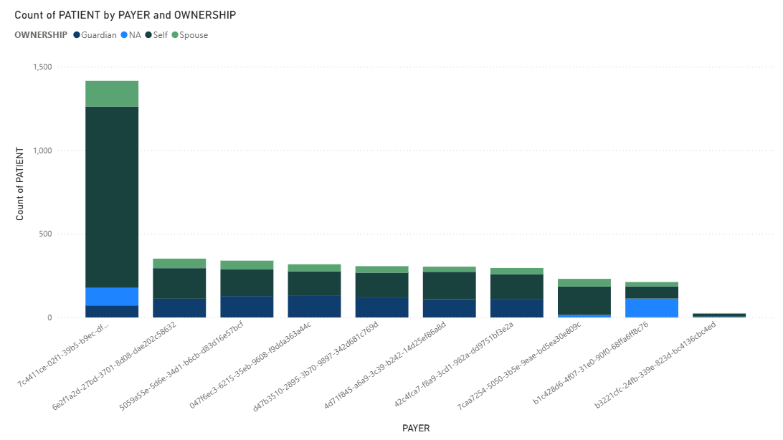

• **Visualisation Type and Purpose:** This stacked column chart illustrates patient distribution across different payers while distinguishing between payer ownership categories (e.g., self, spouse), allowing for simultaneous comparison.

• **Key Insights:** The chart highlights patient movement patterns between payers and the balance between private and public ownership in insurance coverage. High counts in a specific payer or ownership type suggest greater retention or preference within the dataset.

• **Data Analysis Perspective:** This visual is valuable for market analysis, understanding insurance plan loyalty, and assessing the competitive landscape of the healthcare payer sector, potentially informing marketing and retention strategies.

## 13. Payers

**Visual 1: 100% Stacked Column Chart – Sum of Covered vs. Uncovered Encounters by Payer Name**

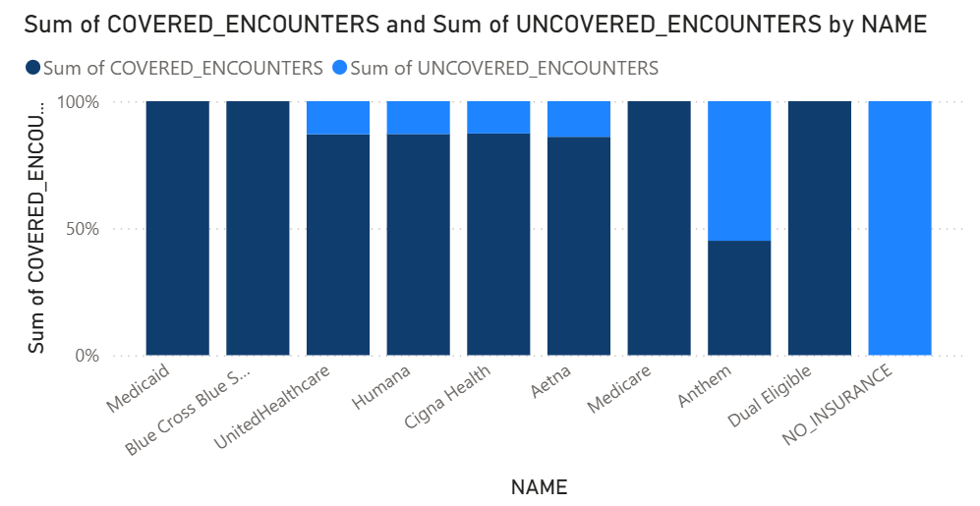

• **Visualisation Type and Purpose:** This 100% stacked column chart compares the proportion of covered to uncovered encounters across different payers, normalising to 100% to emphasise the relative balance.

• **Key Insights:** The chart highlights which payers provide the most comprehensive coverage and which leave a higher proportion of encounters uncovered, supporting quick benchmarking of payer effectiveness.

• **Data Analysis Perspective:** This visual enables robust benchmarking of payer performance, facilitates the identification of coverage gaps, and can inform policy adjustments or guide consumer choice in insurance plans.

**Visual 2: Line and Stacked Column Chart – Sum of Member Months and Sum of Revenue by Payer Name**

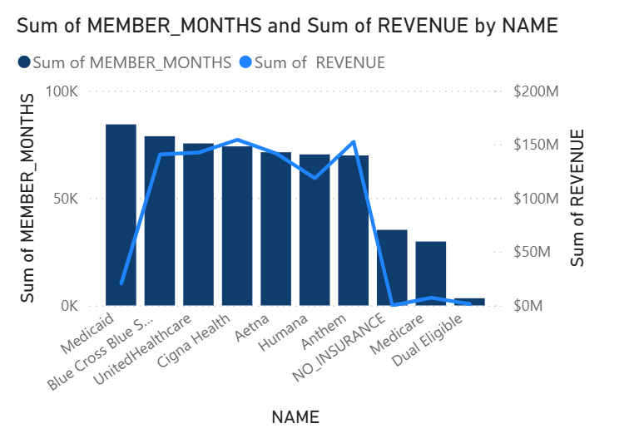

• **Visualisation Type and Purpose:** This combined chart uses stacked columns for the sum of member months and a line for the sum of revenue by payer name, offering two complementary financial measures.

• **Key Insights:** The chart provides a dual perspective, highlighting how payer revenue aligns with patient membership duration. Payers with both high revenue and high member months indicate strong retention and financial strength.

• **Data Analysis Perspective:** This visual provides a holistic view of payer financial health and market stability, offering insights into efficiency, customer loyalty, and potential areas for market expansion or operational improvement.

**Visual 3: Scatter Plot – Amount Covered vs. Member Months by Payer Name and QoLS Average**

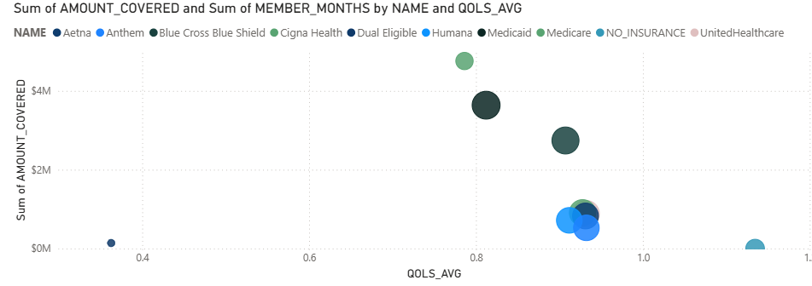

• **Visualisation Type and Purpose:** This scatter plot analyses payers by plotting the amount covered against member months, with the average Quality of Life Score (QoLS_avg) as an additional dimension.

• **Key Insights:** This visualisation highlights payer performance in balancing coverage amounts, membership retention, and the impact on quality of life. Payers positioned towards higher values reflect stronger contributions across financial and quality dimensions.

• **Data Analysis Perspective:** This visual offers a multi-dimensional assessment of payer value, integrating financial and quality metrics. It is crucial for strategic decision-making, performance evaluation, and identifying payers that excel in comprehensive patient care.

## 14. Procedures

**Visual: Area Chart – Average of Base Cost by Year**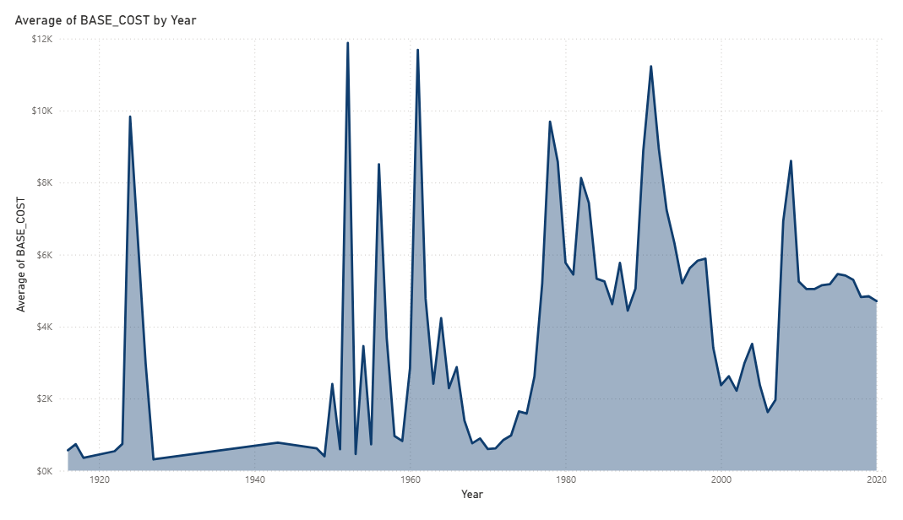

• **Visualisation Type and Purpose:** This area chart tracks the average base cost of procedures across years, emphasising both the magnitude and progression of costs over time.

• **Key Insights:** The chart highlights cost dynamics within clinical procedures. A steady rise may indicate inflationary trends or increasing complexity of treatments, while sudden dips could reflect shifts in care protocols or changes in coding practices within the dataset.

• **Data Analysis Perspective:** This is essential for cost control initiatives, understanding healthcare inflation, and evaluating the economic impact of changes in clinical practice or technological advancements.

## 15. Providers

**Visual 1: Map – Sum of Utilization by ZIP**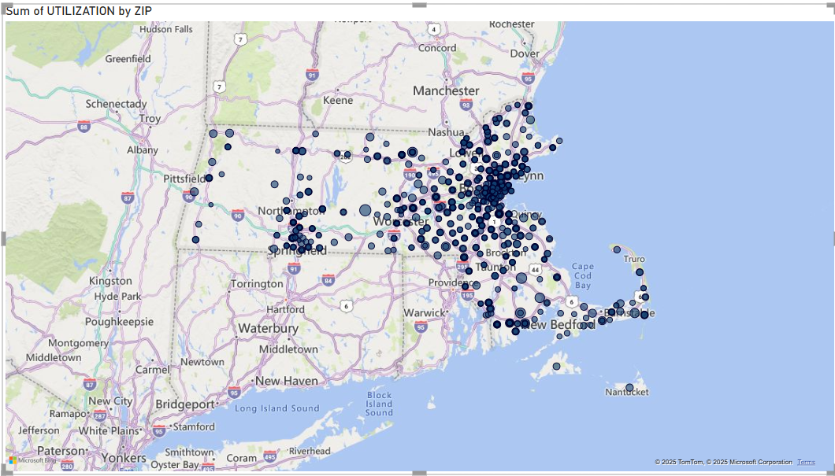

• **Visualisation Type and Purpose:** This map plots healthcare providers geographically using ZIP code locations, with the size or intensity of each marker corresponding to the sum of utilisation.

• **Key Insights:** The map highlights geographic differences in provider utilisation. High-intensity areas suggest greater healthcare demand or provider concentration, while lower-intensity areas may indicate underserved regions.

• **Data Analysis Perspective:** This visual supports geographic market analysis, identifies underserved areas, and aids in optimising resource distribution for healthcare services, potentially guiding the establishment of new facilities or outreach programmes.

**Visual 2: Stacked Bar Chart – Count of Organizations by Specialty**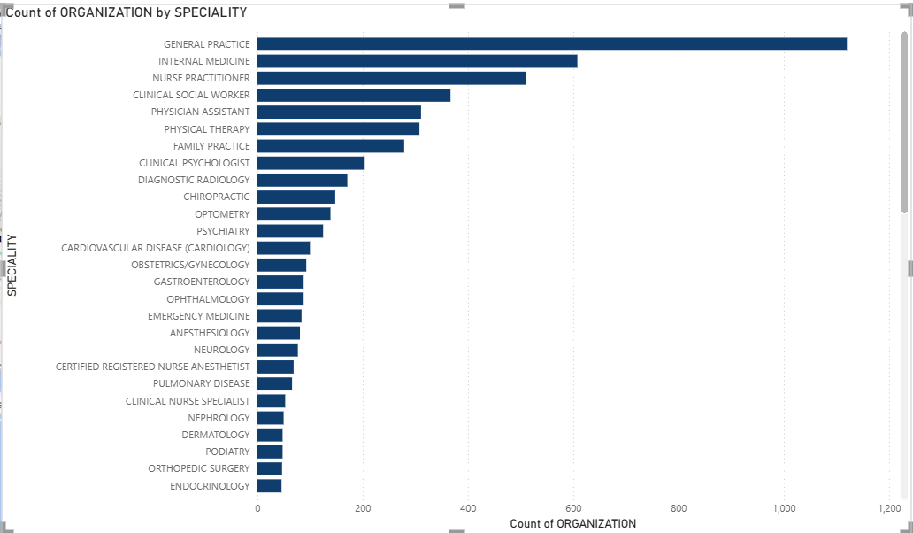

• **Visualisation Type and Purpose:** This stacked bar chart categorises providers by their specialty (e.g., cardiology, pediatrics, general practice) and shows the count of organisations associated with each.

• **Key Insights:** The chart highlights workforce distribution across specialties. A higher count in one specialty suggests a strong presence in that area of care, while smaller segments reveal gaps or less common specialties.

• **Data Analysis Perspective:** This visual informs workforce planning, recruitment strategies, and understanding the capacity and distribution of the healthcare system across various specialty areas.

## Conclusion

The visualisations presented in this report offer a clear and comprehensive understanding of key aspects within the healthcare dataset. They provide crucial insights across several domains:

Firstly, in terms of **clinical and public health**, the analysis identifies common patient allergies, prevalent conditions, and effective vaccination rates, contributing to better clinical awareness and targeted health interventions.

Secondly, for **operational and resource management**, the report reveals trends in careplan adoption, seasonal patterns in observations, and the utilisation of various medical devices and imaging modalities, which are vital for optimising workflows and equipment procurement.

Thirdly, from a **financial perspective**, the visualisations track healthcare expenditure trends, evaluate payer coverage for medications and encounters, and map the revenue contributions of healthcare organisations, supporting cost control and economic analysis.

Finally, in terms of **demographic and equity insights**, the report details healthcare expenses and coverage by gender, marital status, and ethnicity, alongside provider utilisation patterns and workforce distribution, essential for addressing disparities and strategic planning.

Collectively, these visual insights serve as an invaluable tool for stakeholders, enabling data-driven decisions that enhance patient care, optimise resource allocation, and refine healthcare strategies for improved service delivery.

Bottom of Form